DIGESTIVE SYSTEM EXAM

WORD/PHRASE BANK FOR QUESTIONS 1.-8 (NOT ALL ARE USED).
ENZYME | LOCATION ENYME IS MADE  Be Organ/Area Specific | ORGANIC COMPOUND BROKEN DOWN  Protein / Carbohydrate / Lipid / Nucleic Acid
SALIVARY AMYLASE | 1.
LINGUAL LIPASE |  | 2.
PEPSIN & TRYPSIN | 3.
HORMONES | FUNCTION
CCK | 4.
GIP | 5.
HCl | 6.
Peptidase turn peptides into: | 7.
Pancreatic & Salivary Amylase turn starch into? | 8.
BANK FOR 1-3
A. MOUTH
B. PANCREAS
C. STOMACH
D. SMALL INTESTINE
E. LIPID
AB. PROTEIN
AC. NUCLEIC ACID
AD. CARBOHYDRATE

BANK FOR 4-6
A. TRANSFORMS PEPSINOGEN
INTO PEPSIN, DENATURES PROTEINS, KILLS MICROBES
IN FOOD
B. ABSORBTION OF B12 FOR
RBC PRODUCTION
C. STOMACH= DECREASE EMPTYING, PANCREAS= INCREASED DIG ENZYME RELEASE (WHEN FAT &
PROTEINS PRESENT)
D. STOMACH= DECREASE SECREATIONS, MOTILITY EMPTYING, PANCREAS= INCREASE INSULIN (WHEN FATTY ACID/SUGAR PRESENT)
E. STOMACH= DECREASES STOMACH SECRETIONS, PANCREAS= INCREASES SODIUM BICARBONATE

BANK FOR 7 & 8
A. FAT DROPLETS
B. MALTOSE
C. AMINO ACID
D. GLUCOSE
E. GYCEROL & FATTY
ACID

MULTIPLE CHOICE:
9. Which of the following is not an accessory organ
a-pancreas b-liver c-esophagus d-gallbladder

10. Which of the following is not a tissue layer of the alimentary canal
a-mucosa b-muscularis c-secretin d-serosa

11. Which sphincter is associated with the stomach
a-oddi b-pyloric c-internal involuntary d-external voluntary

12. Which is not a salivary gland
a-parotid gland b-sublingual gland c-maxillary gland d-submandibular gland

13. Which word does not belong with the liver
a-right lobe b-hepatocyte c-common bile duct d-hydrochloric acid
14. Each of the following organs is a component of the digestive tract except one. Identify the exception.
A) spleen B) esophagus C) stomach D) colon E) pharynx

15. Which of the following is an accessory organ of digestion?
A) esophagus B) colon C) pancreas D) spleen E) stomach

16. “Digestion”, alone, refers to the (very specific answer)
A) absorption of nutrients in the gut. B) progressive dehydration of indigestible residue.
C) input of food into the digestive tract. D) chemicall/mechanical breakdown of food.
E) mixing of nutrients with digestive enzymes.

17. Which of the following is NOT a digestive function?
A) filtration B) absorption C) mechanical processing D) ingestion E) compaction
18. The mucous epithelium is a component of the
A) muscularis. B) adventia. C) submucosa. D) mucosa. E) serosa.

19. Contraction of the __________ layer of the intestinal wall functions to change the shape of the intestinal
lumen and moves food through its length.
A) mucosa B) submucosa C) adventitia D) serosa E) muscularis

20. Large blood vessels and lymphocytes are found in the
A) muscularis. B) mucosa. C) serosa. D) adventitia. E) submucosa.

21. Waves of muscular contractions that propel the contents of the digestive tract from one point to another is/are
A) segmentations. B) mastications. C) pendulum D) peristalsis. E) churning

22. The functions occurring within the oral cavity include
A) analysis of material before swallowing and partial digestion of proteins and carbohydrates.
B) lubrication.
C) mechanical processing of food.
D) B and C only.
E) all of the above.

23. __________ types of salivary glands secrete into the oral cavity.
A) Five B) Three C) Four D) Two E) One

24. Teeth are similar to bone and contain a mineralized matrix called
A) pulp. B) enamel. C) dentin. D) periodontium. E) cementum.

25. The crown of a tooth is covered by
A) pulp. B) dentin. C) cementum. D) enamel. E) periodontium.

26. During swallowing,
A) the larynx elevates. B) the upper esophageal sphincter opens.
C) the soft palate elevates. D) the epiglottis closes. E) all of the above occur.

27. Secretions from the salivary glands
A) are digestive enzymes. B) help to lubricate the oral cavity and its contents.
C) help to control bacterial populations in the mouth. D) do B and C only.
E) do all of the above.

28. The __________ teeth are used for crushing or grinding food.
A) incisors B) molars C) bicuspids D) canines E) cuspids

29. The __________ are pointed teeth that are adapted for tearing and shredding.
A) incisors B) bicuspids C) molars D) cuspids E) wisdom teeth

30. There are ________ primary teeth and __________ permanent teeth
A) 20, 32 B) 32,20 C) 30, 20 D) 20, 30 E) 34, 24

31. The esophagus
A) is a muscular tube. B) extends from the oropharynx to the stomach.
C) functions in digestion of carbohydrates. D) has a thick lining that will tolerate stomach acid.
E) exhibits all of the above.

32. Functions of the stomach include
A) mechanical breakdown of food. B) storage of recently ingested food.
C) denaturation of proteins. D) initiation of protein digestion. E) all of the above.

33. The portion of the stomach that connects to the esophagus is the
A) cardia. B) body. C) pylorus. D) fundus. E) antrum.

34. The bulge of the greater curvature of the stomach superior to the esophageal junction (or the big wheel) is the
A) pylorus. B) fundus. C) antrum. D) cardia. E) body.

35. The large area of the stomach between the fundus and the J-curve, where most digestion occurs is the
A) pylorus. B) fundus. C) cardia. D) antrum. E) body.

36. The curved, tubular portion of the stomach is the
A) fundus. B) body. C) pylorus. D) cardia. E) antrum.

37. Gastric pits are
A) holes in the body of the stomach. B) located in the esophagus.
C) involved in absorption of liquids from the stomach. D) areas where proteins are digested.
E) pockets in the lining of the stomach that contain secretory cells.

38. The enzyme pepsin digests
A) vitamins. B) carbohydrates. C) proteins. D) lipids. E) nucleic acids.

39. Plicae Circularis and intestinal villi
A) produce new cells for the mucosa of the small intestine.
B) carry products of digestion that will not pass through the walls of blood capillaries.
C) produce hormones to aid in digestion.
D) secrete digestive enzymes to aid in digestion.
E) increase the surface area of the mucosa of the small intestine & aid in absorption.

40. The portion of the small intestine that is attached to the pylorus of the stomach is the
A) duodenum. B) colon. C) jejunum. D) ileum. E) cecum.

41. The middle portion of the small intestine is the
A) duodenum. B) jejunum. C) pylorus. D) ileum. E) cecum.

42. The portion of the small intestine that attaches to the large intestine is the
A) cecum. B) ileum. C) appendix. D) duodenum. E) jejunum.

43. Intestinal hormone that stimulates the pancreas to release a watery secretion that is high in bicarbonate ion is
A) enterocrinin. B) secretin. C) cholecystokinin (CCK) D) gastrin. E) GIP.

44. An intestinal hormone that stimulates the gall bladder to release bile is
A) secretin. B) cholecystokinin (CCK) C) GIP. D) gastrin. E) enterokinase.

45. The fusion of the hepatic duct with the cystic duct forms the
A) bile canaliculus. B) porta hepatis. C) common pancreatic duct.
D) common bile duct. E) hepatic portal vein.

46. The human liver is composed of 4 lobes. Which is lobe is larger…(A) Right Lobe….(B) Left Lobe?

47. An enzyme that will digest proteins into polypeptides is
A) maltase. B) lipase. C) trypsin. D) amylase. E) nuclease.

48. The enzyme amylase helps to digest
A) carbohydrates. B) fats. C) proteins. D) lipids. E) nucleic acids.

49. During the cephalic phase of gastric secretion,
A) production of gastric juice slows down. B) secretin inhibits parietal and chief cell action.
C) the stomach responds to distention. D) the intestine reflex inhibits gastric emptying.
E) there is an increased flow of action potentials along the vagus nerve to the stomach.

50. Decreased levels of bile salts in the bile would interfere with
A) digestion of vitamins. B) fat digestion. C) protein digestion.
D) digestion of disaccharides. E) digestion of complex carbohydrates.

51. During defecation,
A) the external anal sphincter is consciously relaxed.
B) stretch receptors in rectal wall activate parasympathetic centers in the sacral region of the spinal cord.
C) stretch receptors in the rectal wall initiate a series of peristaltic contractions in the colon and rectum.
D) the internal anal sphincter relaxes.
E) all of the above occur.

MATCHING: (Words may be used more than once or NOT at all)
A-CECUM B-EPIGLOTTIS C-PERISTALSIS D-12 FEET
E-CHYME AB-5 FEET AC-MASTICATION AD-PEYERS PATCHES AE-GALLBLADDER BC-SALIVARY AMYLASE BD-20 FEET BE-LIVER
CD-BOLUS CE-GLOTTIS DE-DUODENUM

52. Movement of food by a series of muscular contractions and relaxation
53. The ability to chew food is also known as…
54. This enzyme begins the chemical digestion of starchy foods
55. When swallowing food, first the soft palate rises so food won’t go up your nasal cavity then this structure
bends over to cover glottis
56. This is the material that is ready to enter the small intestine which was converted
by chemical & mechanical digestion into a semi-fluid paste of small food particles & gastric juice
57. This is the first section that the material hits after it has left the small intestine and has entered the large
intestine
58. This is how long the large intestine is in feet
59. The ileum is how long
60. This organs major function is to store and concentrate bile
61. This pouch-like structure is the first part of the large intestine

Match the structure of the digestive system with its function.

A. dehydration and compaction of indigestible materials in preparation
62. Pancreas for elimination
63. Liver B. secretion of bile (important for lipid digestion), storage of
64. Small Intestine nutrients, many other vital functions
65. Esophagus C. storage and concentration of bile
66. Gallbladder D. transport of materials to the stomach
67. Stomach E. secretion of buffers and digestive enzymes by exocrine cells;
secretion of hormones by endocrine cells
AB. mechanical processing, moistening, mixing with salivary secretions
AC. chemical breakdown of materials by acid and enzymes; mechanical processing through muscular contractions
AD. secretion of lubricating fluid containing enzymes that break down
carbohydrates
AE. enzymatic digestion and absorption of water, organic substrates,
vitamins and ions
BC. pharyngeal muscles propel materials into esophagus

CLINICAL TERMS MATCHING
Word Bank for Clinical Terms 68-70
- Bloating of the Abdomen
- Difficulty swallowing.
- Pancreatic tissue and duct are digested
- Grinding or clenching teeth
- Inflammation of the small intestines (usually).
AB. Branch of medicine dealing with diseases of the colon,
rectum and anus
AC. Binge/Purge behavior-self induced vomiting
AD. Pyloric sphincter is abnormally constricted
AE. Dryness of the mouth
rectum and anus
68. Ascites
69. Bruxism
70. Dysphagia

WORD BANK QUESTIONS
71-78

- ESOPHAGUS
- PARATOID GLAND
- SUBMAXILLARY GLAND
- SUBMANDIBULAR GLAND
- SUBLINGUAL GLAND
AB. STOMACH
AC. LIVER
AD. GALLBLADDER
AE. DESCENDING COLON
BC. ASCENDING COLON
BD. TRANSVERSE COLON
BE. PANCREAS
CD. ILEUM
CE. DUODENUM
DE. SIGMOID COLON
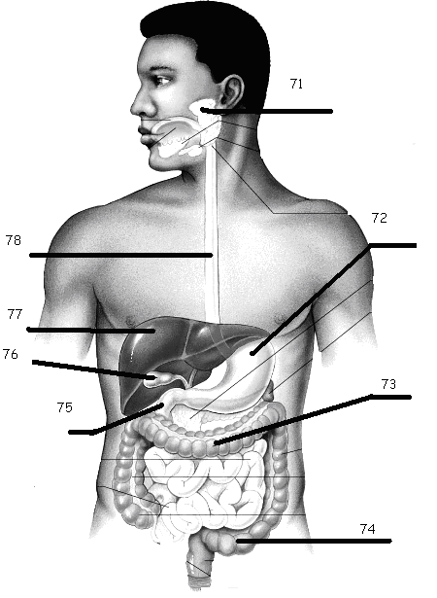
WORD BANK QUESTIONS
79-87
- ROOT
- LESSER CURVATURE
- RUGAE
- GREATER CURVATURE
- CROWN
AB. CIRCULAR LAYER
AC. ENAMEL
AD. LONGITUDINAL LAYER
AE. OBLIQUE LAYER
BC. DENTIN
BD. PULP CAVITY
BE. SEROSA
CD. DUODENUM

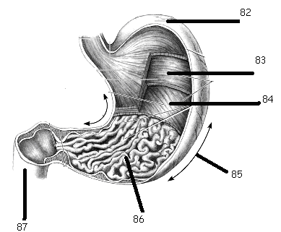
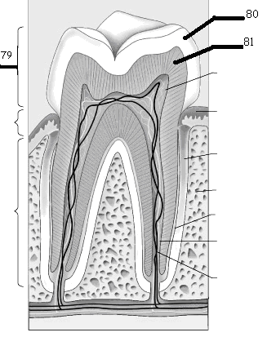

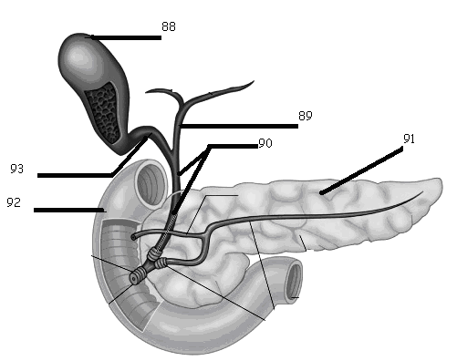
WORD BANK QUESTIONS
88-100

A. COMMON HEPATIC DUCT
B. ILEOCECAL VALVE
- COMMON BILE DUCT
- CYSTIC DUCT
- RECTUM
AB. PANCREAS
AC. APPENDIX
AD. GALLBLADDER
AE. DESCENDING COLON
BC. ASCENDING COLON
BD. TRANSVERSE COLON
BE. ANUS
CD. CECUM
CE. DUODENUM
DE. JEJUNUM
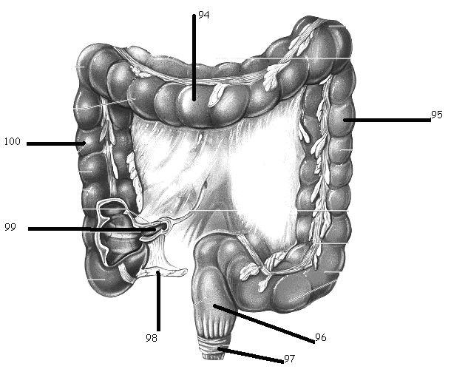

WORD OF THE DAY: BONUS
(PUT THESE ANSWERS ON THE RIGHT SIDE OF THE SCANTRON)
1. ENTR MEANS _______
2. AMYLO MEANS _______
3. ______ MEANS LIVER
4. ______ MEANS STOMACH

