SKELETAL SYSTEM EXAM

Multiple-Choice: Choose the one alternative that best completes the statement or answers the question.

1) The appendicular skeleton consists of
A) the bones of the arms. B) the bones that connect the limbs to the axial skeleton.
C) the bones of the legs. D) the bones of the hands and feet.
E) all of the above.

2) Which of the following is NOT a part of the axial division of the skeletal system?
A) ribs B) auditory ossicles C) skull D) vertebral column E) pectoral girdle

3) The following fracture is a:
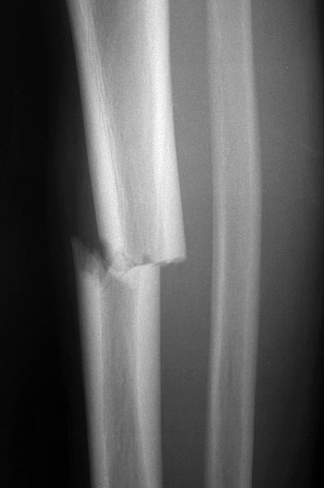
A) Comminuted
B) Compound
C) Transverse
D) Spiral

4) The following fracture is a:

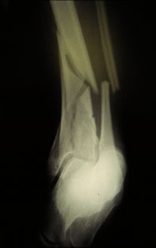
A) Comminuted
B) Greenstick
C) Transverse
D) Spiral

5) The following fracture is a:
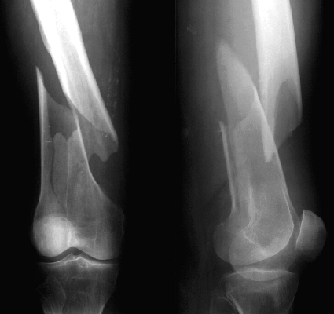
A) Greenstick
B) Comminuted
C) Transverse
D) Spiral

6) The vertebral column contains __________ thoracic vertebrae.
A) 4 B) 5 C) 7 D) 12 E) 31

7) Humans have __________ pair of ribs.
A) 2 B) 6 C) 10 D) 12 E) 24

8) The normal loss of bone that occurs with aging is called
A) osteoporosis. B) osteopenia. C) osteogenesis.
D) osteoinflammation. E) bone cancer.

The following are major steps in the process of Endochondral Ossification
1. Blood vessels invade the perichondrium.
2. 2⁰ ossification center form & epiphysis fill with spongy bone
3. Chondrocytes enlarge and matrix begins to calcify.
4. Osteoblasts form spongy bone within the center shaft at the primary ossification center.
5. Osteoclasts break down some spongy bone to create a marrow cavity.

9) The correct order for the above events is
A) 1, 3, 5, 4, 2 B) 3, 1, 5, 4, 2 C) 3, 1, 4, 5, 2
D) 2, 3, 1, 5, 4 E) 1, 5, 3, 4, 2

10) The narrow passageways that contain cytoplasmic extensions of osteocytes are termed
A) lamellae. B) lacunae. C) marrow cavities. D) matrices. E) canaliculi.

11) A centrally located foramen magnum indicates
A) Knuckle walking B) Bipedalism

12) The portion of the sternum that articulates with the clavicles is the
A) angle. B) body. C) manubrium. D) tuberculum. E) xiphoid process.

13) Cells that secrete the organic components of the bone matrix are termed
A) osteoblasts. B) chondrocytes. C) stem cells. D) osteocytes. E) osteoclasts.

14) Functions of the skeletal system include
A) support. B) blood cell production. C) storage. D) protection. E) all of the above.

15) The vertebral column contains __________ cervical vertebrae.
A) 4 B) 5 C) 7 D) 12 E) 31

16) The clavicle articulates with the scapula at the
A) scapular spine. B) glenoid tuberosity. C) coracoid process.
D) acromion process. E) subscapular fossa.

17) Large, multinucleated cells that can dissolve the bony matrix are termed
A) stem cells.
B) osteoclasts.
C) chondrocytes.
D) osteocytes.
E) osteoblasts.

18) Mature bone cells are termed
A) chondrocytes. B) osteoblasts. C) osteons. D) osteocytes. E) osteoclasts.

19) Which of the following is NOT a component of the appendicular skeleton?
A) coccyx B) coracoid process C) scapula D) humerus E) femur

20) Each of the following bones is part of the pelvic girdle except one. Identify the exception.
A) ischium B) femur C) acetabulum D) ilium E) pubis

21) Which of the following is the heel bone?
A) calcaneus B) cuboid C) navicular D) talus E) none of the above

22) Improper administration of CPR (cardiopulmonary resuscitation) can break the (what we discussed):
A) xiphoid process B) costal cartilage C) lumbar vertebrae
D) floating ribs E) manubrium of the sternum

23) The presence of an epiphyseal line indicates
A) epiphyseal growth has ended.
B) the bone is fractured at that location.
C) epiphyseal growth is just beginning.
D) the presence of an epiphyseal line does not indicate any particular event.
E) growth in bone diameter is just beginning.

24) In intramembranous ossification,
A) ossification centers form within thickened mesenchyme
B) precursor cells transform into cartilage producing cells
C) bone matrix (osteoid region) undergoes calcification
D) only A and C are true.
E) all of the above are true.

25) The longest and heaviest bone in the body is the
A) humerus. B) coccyx. C) tibia. D) fibula. E) femur.

26) The plates/lattice of bone found in spongy bone are called
A) concentric lamellae. B) lacunae. C) trabeculae. D) interstitial lamellae. E) osteons.

27) The radius articulates with the
A) Scapula. B) Femur C) Metacarpals. D) Ulna E) all of the above

28) One role of the fontanels is to
A) serve as the final bony plates of the skull.
B) lighten the weight of the skull bones.
C) serve as ossification centers for the facial bones.
D) allow for compression of the skull during childbirth.
E) do none of the above

29) Endochondral ossification begins with
A) a cartilaginous model. B) a fibrous connective tissue model. C) a membranous model.
D) a calcified model. E) no model at all, just the presence of osteoblasts

30) Round head fitting into a cup shaped depression (ex: femur/acetabulum) is:
- Hinge joint B) gliding joint C) suture D) ball and socket joint

31) Joints that allow the most movement (Synovial)?
A) Amphiarthrosis B) Diarthrosis C) Synarthrosis

32) Joints that are present between the ribs and the sternum (Cartilaginous)?
A) Amphiarthrosis B) Diarthrosis C) Synarthrosis

33) Joints that are present between the cranial bones (Sutures)?
A) Amphiarthrosis B) Diarthrosis C) Synarthrosis

True/False: A=True, B=False
- The diaphysis is the sheet of dense connective tissue surrounding the outer surface of the long bone.
- The sternum is an irregular bone.
- A foramen is an opening in the bone which allows nerves and blood vessels to pass.
- A trochanter is large, round protuberance.
- The skull, mandible & clavicle are Intramembranous bones.
- Spongy bone is found in the epiphyses
- The central canal that carries blood vessels and nerves in the compact bone is the Haversian Canal

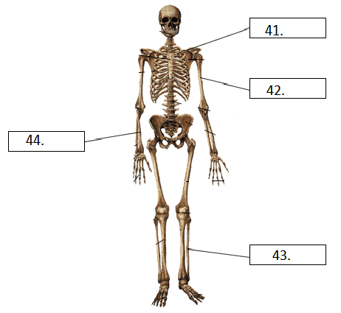
Word Bank for # 41-44
- Ishium
- Ilium
- Tibia
- Fibia
- Clavicle
AB. Humerus
AC. Tibula
AD. Fibula
AE. Radius
BC. Ulna

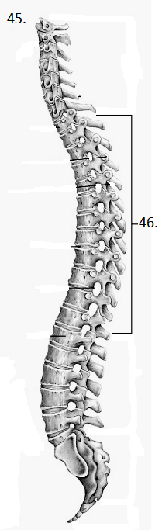
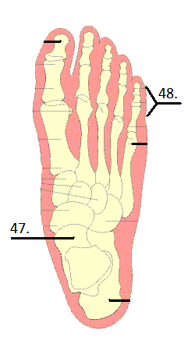
Word Bank for # 45-50
(Use ANY of the answers!!!)

- Ischium
- Phalanges
- Pedal Phalanges
- Manual Phalanges
- Axis
_____________________
A. Atlas
B. Sphenoid Sinus
C. Frontal Sinus
D. Ethmoid Sinus
E. Maxillary Sinus
_____________________
A. Metacarpals
B. Sacrum
C. Lumbar Vertebrae
D. Thoracic Vertebrae
E. Radius

A. Calcaneus
B. Metatarsals
C. Carpals
D. Tarsals
E. Talus

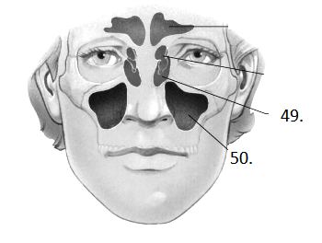

Bone Markings: Questions 51-58

- ________________ = opening
Word Bank for Questions 51-58
- Foramen
- Tuberosity
- Fossa
- Trochanter
- Sulcus
ab. Facet
ac. Meatus
ad. Condyle
- ________________ = shallow depression
- ________________ = groove
- ________________ = tube-like passageway or canal
- ________________ = large, round protuberance
- ________________ = smooth flat articular surface
- ________________ = very large projection
- ________________ = large, rounded, roughened projection

Fill in the following “story” with the words from the following word bank:

- Intramembranous e. osteoblast
- Endochondral ab. chondroblast
- osteocyte ac. lacuna
- chondrocyte ad. Mesenchyme/osteoproginator

59.
Immature bone cells are derived from stem cells called ________________. These cells differentiate into _______________ that secrete matrix. Then these bone cells get stuck in the chamber or, _____________ and are now considered mature bone cells or _____________. This is the process of __________ ossification. Something very similar occurs when cartilage turns to bone. The stem cells will turn in to cartilage producing cells called _____________. They will secrete matrix as well and get stuck in their chamber and then be considered adult cartilage cells called _____________. This is a part of ____________ ossification.
60.
61.
62.
63.
64.
65.
66.

Diseases:

67. Lateral bending of the vertebral column…
a. Lordosis b. Kyphosis c. Scoliosis d. Lumbardosis

68. Exaggerated thoracic curvature of the spine…
a. Lordosis b. Kyphosis c. Scoliosis d. Lumbardosis

69. Exaggerated lumbar curvature of the spine…
a. Lordosis b. Kyphosis c. Scoliosis d. Lumbardosis

70. A childhood disorder involving the softening and weakening of bones…
a. Osteoporosis b. Rickets c. Gout d. Rheumatoid Arthritis

71. An autoimmune disease where the immune system attacks its own joints often leading to deformities…
a. Osteoporosis b. Rickets c. Gout d. Rheumatoid Arthritis

Joints: Refer to the picture below to answer questions 72-75.
There may be more than one answer for each question.

72. Cartilaginous Joints include which of the following pictures (may choose more than one)?
73. Fibrous Joints include which of the following (may choose more than one)?
74. Synovial Joints include which of the following (may choose more than one)?
75. Which bone is completely immovable?
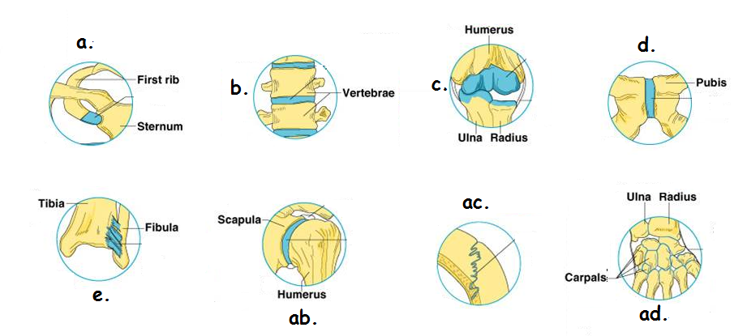

Axial vs. Appendicular: (A) = True, (B) = False

76. The sternum is axial.
77. The coccyx is appendicular.
78. The acromion is appendicular.
79. The occipital bone is axial.
80. I am glad this is almost over!!!

Go to the skeletons in the front of the room.
Look for the labels and match them to the choices in the word bank below.

81. 1 is the …
82. 2 is the …
WORD BANK FOR SKELETON PRACTICAL

a. Clavicle ab. Tibia
b. Temporal ac. Ulna
c. Mandible ad. Metatarsals
d. Ischium ae. Carpals
e. Ilium bc. 6
bd. 7
be. 8
cd. 9
ce. 10

83. 3 is the …
84. 4 is the …
85. 5 is the …
86. Which number is the talus?
87. Which number is the coracoid process?
88. Which number is the hyoid?
89. Which number is the humerous?
90. Which number are the metacarpals?

Bonus Words of the Day
Answers on green line of the scantron
- ______ means “bone”
- _____ means “marrow”
- “Cervic” means _____
- “Clast” means _____

